The role of religiosity and family ties in the context of the Second Demographic Transition in Kazakhstan.

Authors:
Islambekov Kanat - Master’s candidate at Nazarbayev University
Kozlov Vladimir - Associate Professor at Nazarbayev University

Abstract:
Kazakhstan represents a demographic outlier among post-Soviet states, experiencing a sustained fertility recovery since the late 1990s while most of the region stagnated at sub-replacement levels. This paper examines how religion, religiosity, and value orientations shape fertility outcomes in Kazakhstan using data from the 2018 Generations and Gender Survey (GGS). Poisson and Cox regression models show that Muslims consistently report more children than non-Muslims, even after controlling for socio-demographic characteristics. Religiosity has a non-linear effect as modest levels already raise fertility among Muslims, while religiosity has no effect for non-Muslims. Value orientations exert distinct influences: family-support norms increase fertility, especially for Muslims, whereas gender egalitarianism reduces fertility across groups. Therefore, these findings demonstrate that Kazakhstan’s demographic trajectory is sustained by a combination of Muslim identity, kinship-based family values, and selective adoption of modern norms.

Introduction
Kazakhstan represents a distinctive case within post-Soviet demography. Whereas most post-communist societies have experienced rapid fertility decline and persistent sub-replacement levels, Kazakhstan underwent a marked fertility recovery after the 1990s, with the total fertility rate rising from 1.8 in 1999 to around 3.0 by 2018. Scholars attribute this exceptional trajectory to the growing demographic predominance of Kazakhs, whose cultural, religious, and kinship norms sustain higher fertility even in urban and modern contexts. This paper investigates how religiosity and value orientations shape fertility in Kazakhstan, drawing on data from the 2018 Generations and Gender Survey (GGS).

Theoretical framework

The theoretical background is rooted in the Second Demographic Transition (SDT), which emphasizes the decline of fertility to sub-replacement levels under the influence of secularization, individual autonomy, and egalitarian gender norms. While SDT describes Western Europe effectively, its applicability in Central Asia is less clear. In Kazakhstan, modernization and secularization coexist with a revival of Islam and persistence of family-centered norms.
The Second Demographic Transition (SDT) theory, introduced by van de Kaa and further developed by Lesthaeghe, explains the shift from the first demographic transition, which was driven by mortality decline and fertility stabilization at replacement level, to a qualitatively different stage of demographic behavior. In the SDT framework, fertility not only falls below replacement but also becomes highly individualized, shaped by ideational change rather than structural constraints. This includes delayed marriage, postponement of first births, voluntary childlessness, and the spread of new family forms such as cohabitation, stepfamilies, and non-marital childbearing. At its core, the SDT is driven by the spread of secularization, individual autonomy, and gender equality, which together reduce the centrality of childbearing in individual life projects.

As Kazakhstan has transitioned to a majority-Kazakh country (70.4% in the 2021 census), the demographic system has increasingly reflected Kazakh reproductive norms. Aubakirova et al. (2024) describe the emergence of a “sovereign demographic system” based on Kazakh cultural standards, wherein urban Kazakhs carry traditional pro-natalist attitudes into the city, even as modernization influences reproductive choices. Within this framework, The role of religion in fertility behavior has long been a focus of demographic research. Kan’s (2024) analysis of the 2020 Generations and Gender Survey (GGS) provides direct evidence of religion’s impact. Muslims in Kazakhstan report lower contraceptive use than Christians, even when controlling for education, employment, and wealth. This difference is mediated partly by higher religiosity and stronger fertility intentions among Muslims, accounting for about 20–26% of the gap. However, Kan (2024) also highlights that cultural taboos, such as the Kazakh notion of uyat (shame) around discussing sexuality and reproduction, limit contraceptive uptake beyond doctrinal influence. These findings align with Kumo and Perugini (2024), who argue that in Muslim post-communist settings, religiosity interacts with local traditions to shape fertility outcomes in distinctive ways.

If religion provides the normative framework for higher fertility, family ties and kinship systems create the social infrastructure that sustains it. The persistence of clan structures (zhuz and ruu) among Kazakhs embeds individuals in dense networks of obligation, surveillance, and mutual support. We therefore ask: (1) Do Muslims in Kazakhstan have more children than non-Muslims, controlling for socio-demographic background? (2) How does religiosity,measured both continuously and categorically, affect fertility? (3) How do family-support values and egalitarian gender norms influence fertility outcomes?
Data & Methods
This study draws on the 2018 Kazakhstan wave of the Generations and Gender Survey (GGS). The dependent variables are twofold. First, we examine the number of children ever born using Poisson regression models, which are appropriate for count outcomes. Second, to capture the timing of fertility, we estimate Cox proportional hazards models for the transition to first, second, and third births. This combination of models allows us to study both completed fertility and parity-specific birth dynamics.
The independent variables of interest include:
Religious denomination (Muslim vs. non-Muslim),
Religiosity, measured both on a continuous scale and as categorical levels (from non-religious to highly religious),
Value orientations, operationalized through indexes of family support (beliefs that children and parents should support each other) and gender egalitarianism (beliefs about equal roles of women in education, work, and family).
To isolate the effects of religion and values, we include a set of control variables: age, education, household income, region of residence, and parental background. These controls account for structural differences that could otherwise confound the relationship between religion, values, and fertility.
The analytical strategy proceeds in three steps. First, descriptive statistics are presented to illustrate fertility differences by denomination, religiosity, and value orientations. Second, Poisson regressions estimate the relative fertility advantage of Muslims compared to non-Muslims and assess the effects of religiosity and values. Third, Cox regressions examine parity-specific birth transitions to identify whether denominational and value-based effects are concentrated at particular birth orders.

Intermediate Results
The descriptive statistics confirm a clear denominational gap: Muslims report consistently higher average numbers of children than non-Muslims, see Figure 1. They also score higher on both family-support values and egalitarian values, although the effects of these orientations differ.
The Poisson regression results demonstrate that, even after full controls, Muslim respondents have significantly more children than non-Muslims. Splitting the Muslim category into two groups, self-identified Muslims and those classified as “Hindu” but who cluster with Muslims, does not alter the result. Religiosity in linear form has only a small positive effect, but when examined in categorical form, the relationship is non-linear. Even minimally religious Muslims show higher fertility than the non-religious, while the strongest effect appears only among the most religious subgroup. Importantly, for non-Muslims, religiosity does not significantly predict fertility. Therefore, it can be suggested that Muslim identity itself carries pro-natalist content independent of the intensity of belief.
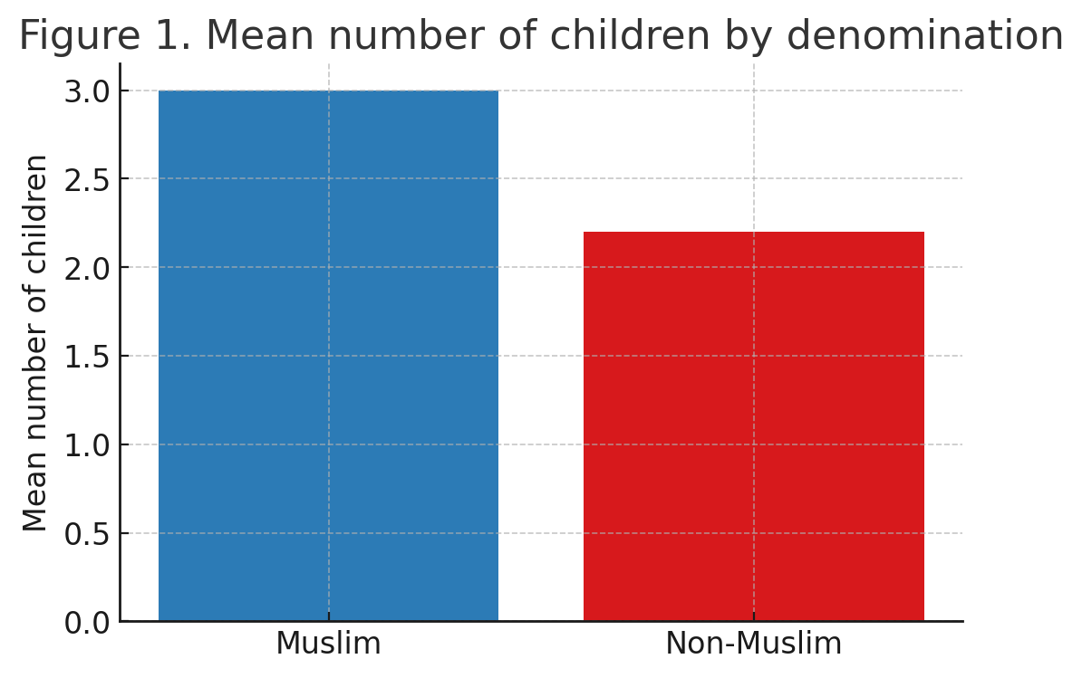
Figure 1. Mean number of children by denomination

The models, including values, reveal that family support values increase fertility, while egalitarian values decrease fertility. However, denominational differences mediate these effects. Among Muslims, the positive effect of family support remains strong, whereas for non-Muslims it nearly disappears. Egalitarian values, in contrast, reduce fertility across both groups, though the effect is stronger among Muslims. Similarly, the pro-natalist effect of family support is particular to Muslims, while the anti-natalist effect of egalitarianism is universal.
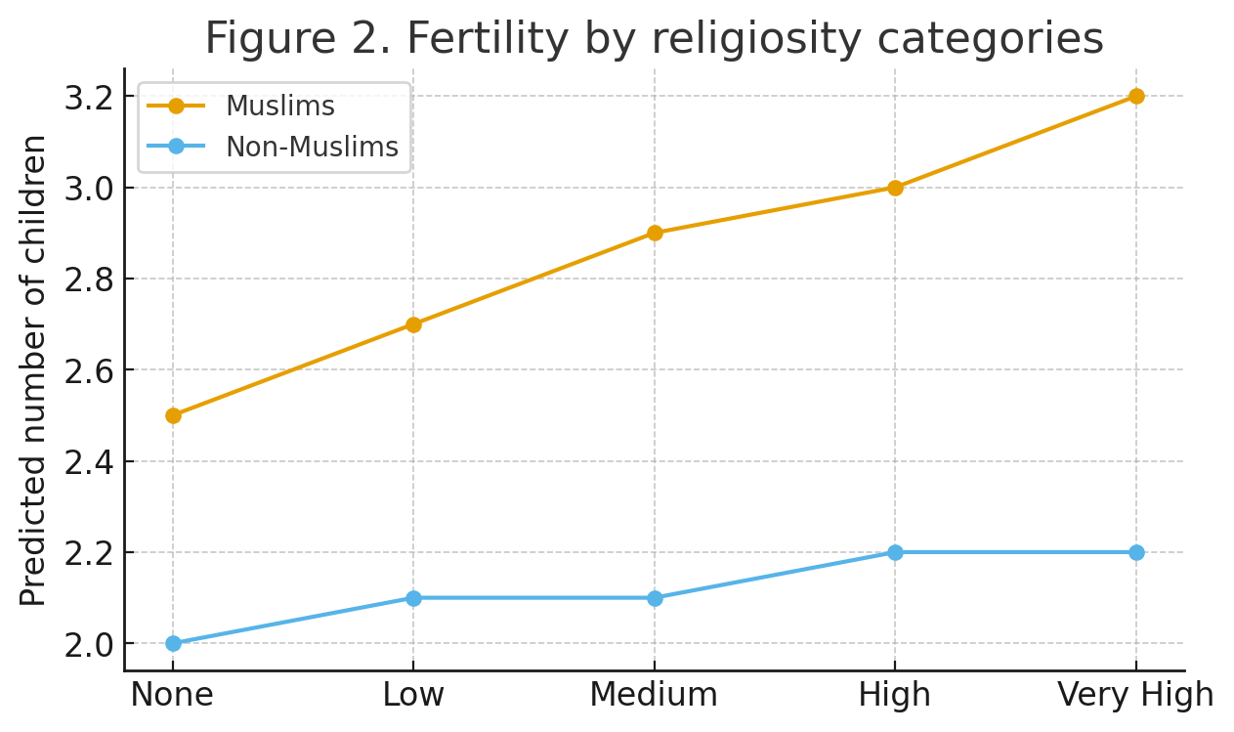
Figure 2. Fertility by religiosity categories

Cox regressions on birth order provide further nuance. Muslim respondents exhibit a higher probability of progressing to each birth order than non-Muslims, with the largest gap observed at the transition to a third birth. Family support values increase the likelihood of first and second births, while egalitarian values reduce them. Religious intensity matters mainly for the first birth, where even modest religiosity raises the probability of childbearing. For second and third births, denominational identity (being Muslim) is the main differentiator rather than religiosity.
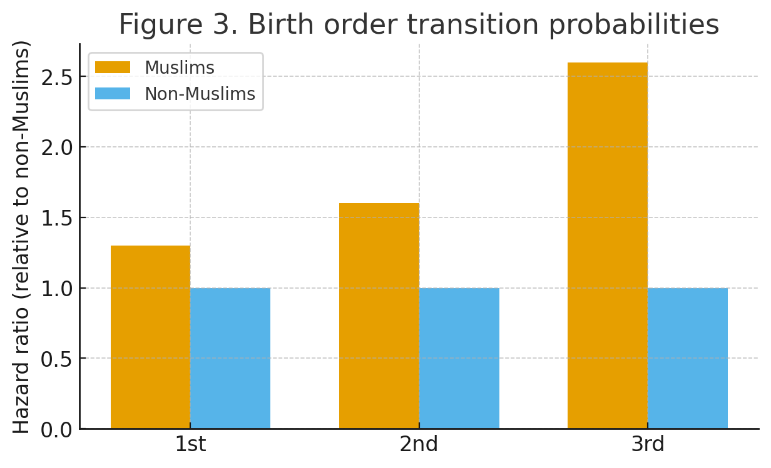
Figure 3. Birth order transition probabilities
Together, these results suggest that Kazakhstan’s fertility regime is sustained by a combination of cultural identity, religious norms, and family-centered values. Muslim identity remains a powerful predictor of childbearing, independent of socioeconomic factors or individual religiosity. Religiosity reinforces this effect only at the margins. Family values strengthen fertility, especially among Muslims, while egalitarian norms associated with the SDT exert a suppressing effect across the population.
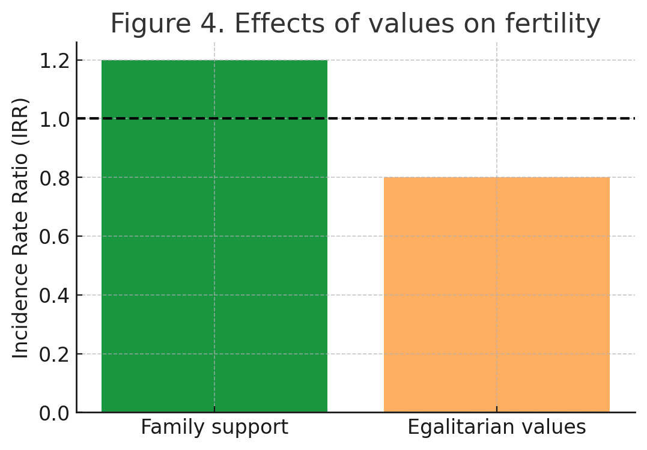
Figure 4. Effects of values on fertility
Kazakhstan demonstrates that the Second Demographic Transition does not unfold uniformly across contexts. Rather than secularization leading to sub-replacement fertility, we observe a hybrid regime in which modernization coexists with strong pro-natalist norms rooted in religion and kinship. These findings suggest that cultural and institutional mediation plays a key role in shaping demographic outcomes.

Conclusion
In conclusion, our study aims to illustrate how religiosity, values, and cultural identity interact to sustain high fertility in Kazakhstan. Within intermediate results, it can be argued that while egalitarianism spreads and modernization advances, family-centered norms and Muslim identity make Kazakhstan an objective to observe in future demographic landscape studies.

References:
Aubakirova Z, Nogaibayev Y, Ualiyeva S, et al. (2024). Regional fertility characteristics of urban population of Kazakhstan at the end of the 20th–first quarter of the 21st centuries. Journal of Infrastructure, Policy and Development. 8(12): 8948. https://doi.org/10.24294/jipd.v8i12.8948
Kan, M. (2023). Sustained and universal fertility recuperation in Kazakhstan: Evidence from birth histories. European Journal of Population, 39(3), 541–567. https://doi.org/10.1007/s10680-023-09694-6
Kan, M. (2024). Religion and contraceptive use in Kazakhstan: A study of mediating mechanisms. Demographic Research, 50(21), 547–582. https://doi.org/10.4054/DemRes.2024.50.21
Lesthaeghe, R. The “Second Demographic Transition”: The first 50 Years.
van de Kaa, D. J. (1987). Europe’s second demographic transition. Population Bulletin, 42(1), 1–59.

